Perforated Duodenal Ulcer
Stem:A 58-year-old woman presents to the emergency department (ED) with a 1-hour history of generalized abdominal pain that began abruptly and now radiates to both shoulders. The patient has a prior history of peptic ulcer disease but is not currently on acid suppression therapy, and s he is on oral steroids for a skin condition. No prior abdominal surgery. D oes not smoke tobacco or drink alcohol.
ED physician calls you and tells you a CT Abdomen is ordered, vitals: T emperature is 36.5°C, heart rate is 100 bpm, blood pressure is 125/70 mm Hg, and her abdomen is diffusely tender to palpation, labs are processing.Any thing else you w ant to order?
- U pright chest x-ray or an abdominal x-ray.
You go to see the patient; X-ray technician just finished the xray you requested?
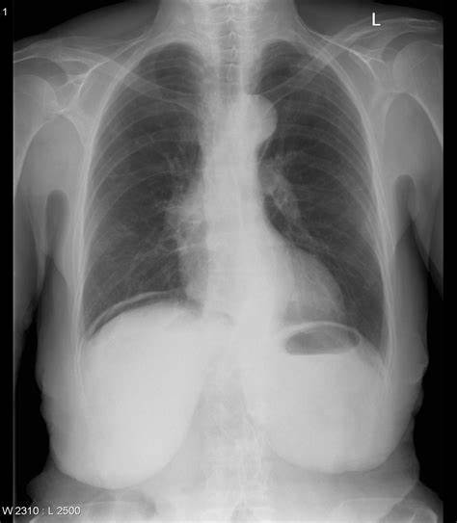

Transport is waiting to take the patient to CT, while you are blood pressure is 90/55 HR 12 6 RR 21. S he is quite but uncomfortable appearing. What would you like to do?
- Resuscitation: IVF, Antibiotics, Foley catheter, NG tube.
- OR for exploratory laparotomy.
On exploration, you identify a 1 cm anterior duodenal perforation. H o w would you address that?
Omental patch.
Patient recovers and get discharged,18 months later she shows up in your clinic with GERD symptoms, despite being on PPIs, you decided to do EGD describe?
- Procedural sedation
- Place in left lateral decubitus position.
- Insert scope into mouth under direct visualization.
- Pass the scope past the cricoarytenoid cartilage into the esophagus.
- Ensuring direct visualization, pass the scope through the esophagus with continuous insufflation in order to visualize the entire esophagus.
- Visualize the gastroesophageal junction and pass into the stomach.

Scenario:Your patient is 52 Y M, prior history of PUD who tells you symptoms had been refractory, patient vitals are within normal range, when you proceed to OR you encounter only minimal contamination, would you consider anything different for this patient?
- Definitive ulcer procedure.
Describe one?
- Truncal vagotomy and pyloroplasty.
  - Isolate the distal esophagus.
  - Identify, dissect, and transect the vagal trunks—send nerve biopsy to pathology.
  - Dissect the distal 6-cm of the esophagus to ensure complete division of vagal fibers.
  - Mobilize the duodenum.
  - Make a longitudinal incision from the antrum onto the proximal duodenum.
  - Place stay sutures at either end of the incision to facilitate transverse closure.
- Antrectomy
  - Free the greater curvature of the stomach.
  - Dissect the first part of the duodenum from the pancreas.
  - Divide the stomach.
  - Ligate the right gastric artery at the level of the pylorus
  - Divide the duodenum just distal to the pylorus—send duodenal stump margin for pathology.
  - Complete with either a Billroth I or Billroth II anastomosis.
- Pa rietal Cell Vagotomy.
  - Divide the lesser omentum from the lesser curvature.
  - Encircle the trunks with Penrose drain and apply tension to facilitate exposure of branches.
  - Dissect and ligate neurovascular branches of the vagal trunks proximal to the crow’s foot of the nerve of Latarjet
  - Skeletonize the distal 6 cm of the esophagus to ensure complete division of criminal nerve of Grassi.

